ADD NEW Result to Results Page (Pre-Add) (Error Example)

ADD NEW Result to Results Page (Post-Add) (Error Example)

ADD NEW Result to Results Page (Pre-Add) (Success Example)

ADD NEW Result to Results Page (Post-Add) (Success Example)

BROWSE all Results from Results Page

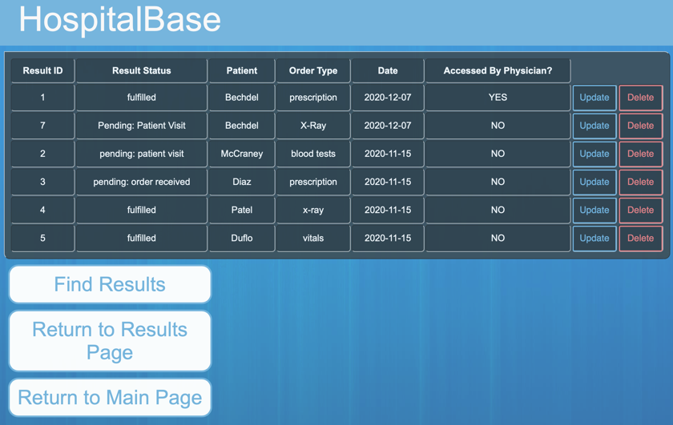

FILTER from Results (Pre-Search)

FILTER from Results Page (Post-Search)

UPDATE a Result from Results Page (Pre-Update)

UPDATE a Result from Results Page (During-Update)

UPDATE a Result from Results Page (Post-Update)

DELETE a Result from Results Page

